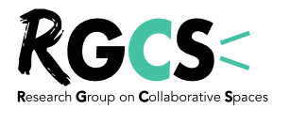 | 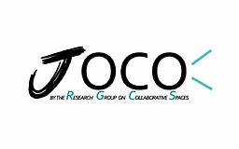

JOCO – Guideline for our open review process

NB: The Journal of Openness, Commons & Organizing (JOCO) follows the rules and spirit of an open review process. This means that our process is much more interactive, transparent and traceable than traditional processes. After the desk stage, authors have an AE from our board and between one and two reviewers who are known to the authors. Ultimately, the paper can be rejected at any time. But we believe this open practice is likely to be much more developmental, community-building and transparent than with other journals. On the other hand, it also means it can sometimes become more affective and time-consuming if not managed properly. Thank for your engagement and investment in our journal!

As AE and reviewers, please fill the following form after each round of reviews.

- Clarity of the research questions and general argument

- Contributions and limitations of the paper for theories, in particular theories about new ways of organizing (work) (1), openness (2) and/or commons (3)

- Contributions of the paper for methodologies (if relevant)

- Contributions and limitations of the paper for organizational practices and public policies

- Respect and fit with open science and openness as lived by RGCS community

Contact for any questions: collaborativespaces@gmail.com

